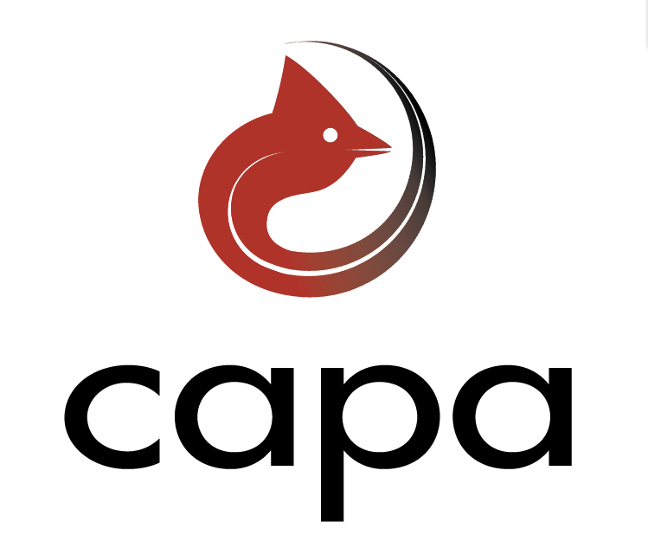 CAPA/NCDOT Asphalt Pavement Workshop 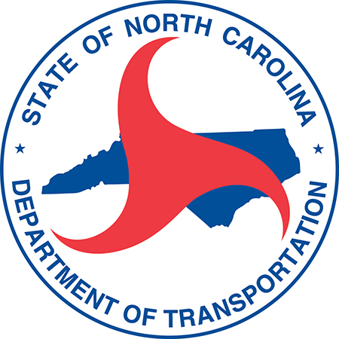
February 23-24, 2015
Hilton Hotel - North Raleigh
Raleigh, NC
Day One - February 23
Registration: 11:00 – 1:30 pm Capital Registration
- Pick up information packets and name tag for meeting
General Session: 1:30-3:00pm Salon ABCDE
- Welcome – Ellis Powell, PE., Executive Director, Carolina Asphalt Pavement Association

- Work Zone Intrusion Prevention Guide – Lee Cole, Oldcastle Materials, VP Environmental Health and Safety

- NCDOT STI and Funding Outlook – Nick Tennyson, NCDOT, Chief Deputy Secretary
Break: 3:00-3:30pm Salon FG
Breakouts: 3:30-5:00pm Salons AB, C, D & E
Breakout Topics
- Breakout A: Construction and Materials - Salon AB
Speakers: Todd Whittington, PE- NCDOT State Asphalt Design Engineer
Wiley Jones, PE – NCDOT Area Roadway Construction Engineer
Clark Morrison, PhD., PE – NCDOT State Pavement Design Engineer
This session will cover the most recent updates to the QMS manual and specifications along with guidance on mix type selection and other pavement and material items related to contract administration.

- Breakout B: Innovation in Asphalt Pavement Equipment– Salon C
Speakers: Chris Frost – Astec, Asphalt Plant Basics and Innovation
Tim Kowalski – Wirtgen America, Intelligent Compaction
Tom Travers – Carlson Paving Products, Longitudinal Joint Construction
This session will cover the mechanics of an asphalt plant, equipment innovation related to asphalt plants, intelligent compaction and longitudinal joint construction.

- Breakout C: Asphalt Surface Treatment – Salon D
Speakers: Nilesh Surti, PE – NCDOT State Pavement Construction Engineer
Emily McGraw, PE – NCDOT State Maintenance Operations Engineer
Sid Witmer – Hammaker East
David Spainhour, PE – SEPI Engineering
This session will cover the most recent legislative requirements regarding Pavement Preservation, NCDOT specification updates, lessons learned and best practices for Asphalt Surface Treatment types.

- Breakout D: National Center for Asphalt Technology (NCAT) Update – Salon E
Speakers:
Jason Nelson – Assistant Research Engineer (NCAT)
This session will cover an update on the test track research results related to thin lift, high RAP/RAS mixes and pavement preservation research resullts.

Reception: 5:00-7:00pm Grand Ballroom

Day Two - February 24
Breakfast: 7:00 – 8:00 am Salon FG
Breakouts: 8:00-9:30am Salons AB, C, D & E
Break: 9:30-10:00am Salon FG
Breakouts: 10:00-11:30am Salons AB, C, D & E
Lunch: 11:30-1:00pm Grand Ballroom
Breakouts: 1:00-2:30pm Salons AB, C, D & E
Break: 2:30-3:00pm Salon FG

General Session: 3:00-4:00 pm Salon ABCDE
- FHWA Initiatives - John Sullivan, PE., FHWA, Division Administrator

- The Highway Fund – Planning, Measuring and Reporting –Mike Holder, P.E.,
NCDOT Chief Engineer
Adjourn: 4:00pm

